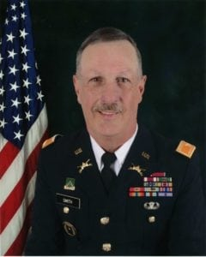 | 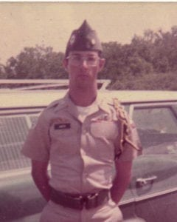
COL (Ret) Kenneth E. Smith
Colonel (Retired) Kenneth E. Smith came to The University of Texas at Arlington in 1971. Born and raised in Fort Worth, he attended Haltom High School in Haltom City, Texas. He was a member of the Corps of Cadets from 1972 to 1976. He was a member of the Sam Houston Rifles Drill Team for four years and was the team’s First Sergeant. He also graduated from the Army Airborne School while a cadet at UTA. Ken graduated from UTA in 1976 with a Bachelor of Arts Degree in History. He later earned a Master of Science degree in Business Administration from Boston University in 1988 and a Master of Strategic Science while attending the Army War College in 2002.
Following his graduation from UTA, Ken was commissioned a Second Lieutenant of Armor in July 1976. His first duty assignment was Active Duty with the 5th Bn, 32d Armor, 24th Inf Div at Fort Stewart, Georgia, from 1977-1979; Ken was assigned to Gelnhausen, Germany from 1979-1982 with the 1st Bn, 33rd Armor. There his duties focused on Installation and Community Support modernization projects. He then served at Fort Polk, Louisiana, from 1983-1988 with the 3rd Bn, 77th Armor and 1st Bn, 40th Armor. Following his extended tour on active duty, Ken was assigned duty with the 75th Maneuver Area Command, and 75th Training Support Division, in Houston, Texas, from 1989-1995. He commanded the 2d Bn, 381st Regt. in Dallas, Texas, from 1995-1998 with the mission of Combat Support unit situational training exercises. He returned to the 75th Division in 1998 until 2000.
Ken was assigned Reserve Duty with the U.S. Army War College from 2002-2006. He returned to extended Active Duty with continuing assignment with the U.S. Army War College, Center for Strategic Leadership from 2005-2006. There he served as Director of the Strategic Leadership Education Program. Mobilized in direct support of Operation Enduring Freedom, his strategic outreach program linked executives, senior strategic leadership, academia, and faculty through strategic leadership topics, communication, and programs. Ken was recognized for his presentation at the Civilian Assistant to the Secretary of the Army (CASA) Conference and the office of the Secretary of the Army for leadership training as part of the Staff Ride at the Gettysburg Battlefield.
In his civilian career, he held a position as District Operations Manager, at RP Kincheloe Company, in Houston, Texas; and dealer representative for products in the medical X-ray field and other medical products from 1988-1994. He then took a position as Warehouse Operations Manager, at MAXXIM Medical from 1994-2000 in Sugarland, Texas. He was the Operations Supervisor for McKesson Medical from 2001-2011 in Grapevine, Texas. In 2012, following a short role as the Operations Manager for PH Casters in Arlington, Texas, Ken became a Security Professional for Allied Barton Security in Westlake and Fort Worth, Texas.
Among COL Smith’s awards are the Legion of Merit, Meritorious Service Medal, Army Commendation Medal 4th Award, Army Achievement Medal 5th Award, National Defense Service Medal with Bronze Star, Army Reserve Components Achievement Medal with Silver Hourglass and M device, Army Reserve Overseas Training Ribbon with numeral 5, and Parachutist Badge.
Ken actively supports the United Methodist Youth programs as sponsor/worker, and he has served as Vice President of the Houston Gymnastics Club/JCC Gymnastics Association.
Ken has a lifelong friend and ex-wife, Janie. He has three children, Melissa, Seth, and Aaron (who passed away in 2011) and 11 grandchildren.

