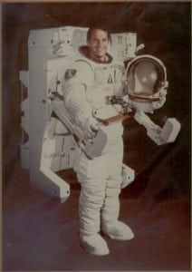 | 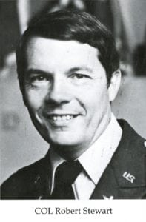
COL (Ret) Robert L. Stewart
Colonel Robert L. Stewart received his Master of Science degree in Aerospace Engineering from the University of Texas at Arlington in 1972. He is honored for his professional achievements and his illustrious career in the United States Army and as a NASA Astronaut.
Colonel Stewart was born august 13, 1942 in Washington, D.C. He graduated from high school in Hattiesburg, Mississippi in 1960 and from the University of Southern Mississippi in 1964 with a Bachelor of Science degree in Mathematics. He is married to Mary Jane Murphy of LaGrange, Georgia and they have two daughters, Ragon Annette and Jennifer Lee.
Colonel Stewart began his military career un Air Defense at the 32nd NORAD Region Headquarters in Alabama in 1964. Two years later, he completed Rotary Wing training and was designated an Army Aviator. He flew 1,035 hours combat time from 1966 to 1967 in Vietnam in the 101st Aviation Battalion. His next assignment was at the U.S. Army Primary Helicopter School as an Instructor and Commander. He is a graduate of the Air Defense officers Advanced Course and the Guided Missile Systems Officer Course. Colonel Stewart served in Seoul, Korea until 1973 with the 309th Aviation Battalion (combat) as Battalion Operations Officer and Executive Officer. He next attended the U.S. Naval Test Pilot School where he completed the rotary Wing Test Pilot Course in 1974. He was then assigned as an experimental test pilot at Edwards Air Force Base in California, where his duties included being Chief of the Integrated Systems test Division, participating in flight tests of UH-1 and AH-1 helicopters and U-21 OV-1 fixed wing aircraft, serving as Project Officer and Senior Test Pilot on the YAH-64 Advanced Attack Helicopter and participation in developing an electronic automatic flight control system for the UH-60A Black Hawk. He has military and civilian experience in 38 types of airplanes and helicopters and has logged approximately 5,400 hours total flight time. Colonel Stewart was selected as an astronaut candidate by NASA in January 1978. After completing a one year training and evaluation of the entry flight control system for STS-1 (the first space shuttle orbital mission), ascent-orbit procedures development and payload coordination. He also served as support crewman for STS-4, and ascent-orbit CAPCOM for STS-5. Colonel Stewart was a mission specialist on space shuttle mission 41-B which launched from Kennedy Space Center on February 3, 1984, and landed eight days later. During this flight, he participated in two extra-vehicular activities (EVA’s) to conduct the first flight evaluations of the manned maneuvering units (MMU’s). With the completion of this flight, he has logged 191 hours in space including 12 hours of EVA operations.
Special honors received by Colonel Stewart include four Distinguished Flying Crosses, a Bronze Star, a Meritorious Service Medal, 33 Air Medals, the Army Commendation Medal with Oak Leaf Cluster and “V” Device, two Purple Hearts, the National Defense service Medal, the U.S. and Vietnamese Vietnam Service Medals, the Vietnamese Cross of Gallantry, and the Army Aviation safety Certification of Recognition. He is also a recipient of the NASA Space Flight Medal (1984).

