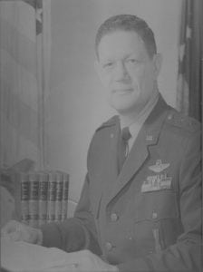 | 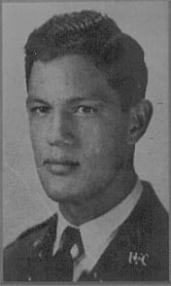
MG (Ret) Harold E. Teubner
Major General Harold Charles Teubner, United States Air force, began his military service as a cadet at North Texas Agricultural College from 1936 to 1939 and retired as a general officer in 1973.
Born in Dallas, Texas in 1919, Major General Teubner attended Sunset High School, Dallas, before beginning his career in the Army Air Corps. He was commissioned through the Aviation Cadet Program at Stockton, California in 1941.
During World War II, Major General Teubner trained heavy bombardment crews and then, in April 1944 was transferred to the China-Burma-India Theater. As lead crew member of one of the first B-29 units, he flew missions covering the Dutch East Indies, Burma, Malaya, China, Formosa, Manchuria, and Japan. After World War II, General Teubner participated in “Project Crossroads,” the first nuclear weapons testing.
General Teubner attended Army Command and General Staff College and then obtained his Master of Science degree from Massachusetts Institute of Technology in 1951. After the Air War College in 1958, General Teubner spends the next three years as Director of Engineering Liaison, 3rd United States Air Force, London, England. After several positions of increasing responsibilities, General Teubner became Auditor General of the Air Force in 1970.
During General Teubner’s distinguished career, his nation recognized him with two Distinguished Service Medals, two legion of Merit Awards, and he earned three Distinguished Flying Crosses, several air medals, and the Air Force Commendation Medal.
Major General Harold C. Teubner was inducted in the Hall of Honor, Military Science Department at The University of Texas at Arlington in October of 1982, in recognition of his achievements and contributions to the country. His beginning as an ROTC cadet and his rise to heights of responsibility and prestige provide an example and incentive for all future officer graduates from the campus at Arlington.

