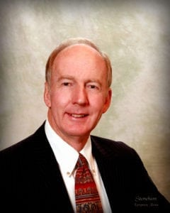 | 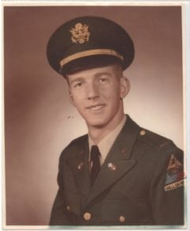
LTC (Ret) Granville E. (Gene) Tyson
Colonel Tyson was born in Elgin, Texas, and raised in Fort Worth. He graduated from Arlington State College in 1964 with a Bachelor of Arts degree in History with a minor in English. While in the Corps of Cadets, he was a member of the pistol team that won the National Collegiate Pistol Championship in 1962. He was commissioned a Second Lieutenant in the Signal Corps in 1964.
He entered active duty at the Officers Basic Course at Fort Gordon, GA. He was then assigned to the 2nd Armored Division at Fort Hood and served as a Platoon Leader. After a year he was reassigned to Fort Gordon as an instructor. Shortly after his promotion to First Lieutenant he left the Army to attend seminary.
Colonel Tyson had felt God’s call while attending ASC but fulfilled his obligation to the Army for two years. He attended Perkins School of Theology at SMU and graduated in 1970 as a United Methodist minister. He served in the Dallas/Fort Worth area until 1978, when he reentered the Army as a chaplain.
His initial assignment as a chaplain was at Fort Ord, CA, where he served the 13th Engineer Battalion. He was chaplain for the Presidio of Monterey and the Post Chapel. Next he attended the Chaplain Officers Advanced Course and was selected to attend a year of advanced civilian schooling at Princeton Seminary, Princeton, NJ. He graduated in 1984 with a Master’s of Theology.
His next assignment took him to Europe, to the Frankfurt Central Chapel. Upon promotion to Major he was assigned to the Religious Retreat Center, Berchtesgaden, Germany. Following that, he was assigned to the office of Chief of Chaplains at the Pentagon, as Homiletics Officer and Editor of the Military Chaplains Review. Returning to Texas, he was assigned to Fort Hood, TX, as Brigade Chaplain, 2nd Brigade, 1st Cavalry Division, and later as the Installation Staff Chaplain. He then went to Korea as Deputy Chaplain, 8th U.S. Army. He returned to Fort Hood and retired in 1996.
He immediately took a position as Program Manager, Mobilization and Deployment Program, Army Community Service at Fort Hood. After four years in this position he was asked by the Texas Cooperative Extension, TAMU, to be Project Officer for Operation READY. Gene and his wife Judy built a house on 25 acres outside Lampasas in 2000, where he started a retreat ministry from his home. In 2004, the 4th Infantry Division asked him to conduct reintegration training when the division returned from Iraq. He was subsequently asked by the 25th Infantry Division in Hawaii and the 1st Armored Division to conduct similar training.
Gene is now Director of Military Training for the CJ Turner Corporation in Austin. He continues to provide reintegration training for units from Fort Huachuca, AZ; Fort Bragg, NC; and Fort Wainwright, AK; and other requests continue to come in. Gene offers retreats to chaplains and their soldiers using his newly constructed Tyson Corners Retreat and Conference Center, opened in 2005.
Colonel Tyson’s military awards include the Meritorious Service Medal (5 awards), Army Commendation Medal (3 awards), and Army Achievement Medal. His service awards include the National Defense Service Medal (2 awards), Armed Forces Reserve Medal, Army Service Ribbon, and Overseas Service Ribbon (2 awards).
Gene and Judy have two daughters and five grandchildren.

