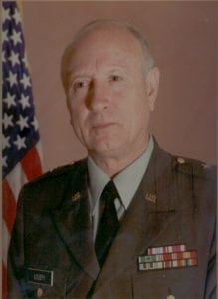 | 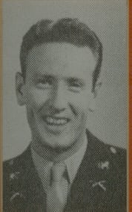
BG (Ret) Elmus S. Ussery
Brigadier General Elmus S. Ussery began his illustrious military service at age sixteen as a cadet at North Texas Agricultural College (NATC) from 1944 to 1947, and is honored for his long and distinguished career in the Army Reserves and in civilian industry.
Born in Fort Worth, Texas in 1927, General Ussery graduated as Salutatorian in 1944 from Diamond Hill High School. He was the first graduate of his school to be honored by an Outstanding Alumnus Award from the Fort Worth Public School System. At NTAC he served as a First Sergeant.
General Ussery entered the Army as a Private in 1950 and served four years on active duty. He received his commission through the Armored Officers Candidate School at Fort Knox, Kentucky in 1952. He was Platoon Leader and Company Commander in the 13th Armored Infantry Battalion of the 3rd Armored Division. General Ussery left active military service in 1953 to return to college. He attended the University of Texas at Austin and received his degree in Economics in 1957. While in college, General Ussery joined the Army National Guard and served as Commander of the 36th Replacement Company, 36th Infantry Division. Later, as an officer in the Army Reserves, he served as Commander of the 168th Support Group, and Assistant to the Executive Director of Supply Operations at the Defense Logistics Agency, Washington, D.C. His last assignment before retirement was as Deputy Chief of Army Reserves at the Pentagon with the rank of Brigadier General.
General Ussery served the city of Louisville, Kentucky as President of the Ussery Corporation, a successful land developing and building business. He received “The Builder of the Year Award” from the Home Builders Association of Louisville, and “The Grand Award for Outstanding Achievements,” National Association of Home Builders. General Ussery has been elected to the highest office in the Army section of the Reserve Officers Association of the United States. He has held numerous advisory board positions, volunteering his time and expertise to professional associations, church and community projects throughout the United States and abroad.
He was a graduate of the Army War College (SRCOC), the Industrial College of Army Forces, Command and General Staff College, National Security Management Course, and many other military schools. His military decorations include the Legion of Merit, Meritorious Service Medal, Army Commendation Medal with one Oak Leaf Cluster, Good Conduct Medal, National Defense Service medal, Armed Forces Reserves Medal with Ten-Year Device and the Army Reserve Components Achievement medal with Oak Leaf Cluster.
From his beginning as a cadet at North Texas Agricultural College and throughout his adult life in his nation’s community’s service, General Ussery has provided an example to all future officer graduates from the campus of the University of Texas at Arlington, the Cadet Corps and the United States Army.

