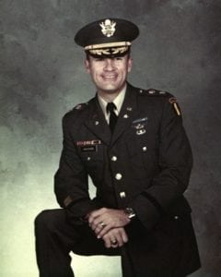 | 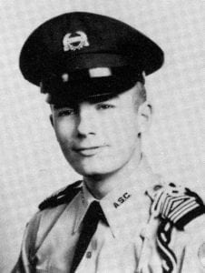
LTC (Ret) Robert P. Vaughan, Sr.
Robert P. Vaughn, Sr. graduated from Sunset High School in Dallas in 1957, and enrolled at Arlington State College. He was a member of the Sam Houston Rifles Drill Team and served as a platoon leader and as the Cadet Corps Sergeant Major, as well as in other staff positions. He graduated in 1962 with a Bachelor’s Degree in History and was commissioned a Second Lieutenant of Infantry.
After completing Infantry Officers Basic Course, airborne, ranger and flight school, he was assigned to Fort Benning with the 11th Air Assault Division (later to become the 1st Cavalry Division (Airmobile)). He served during the highly successful testing of the air mobility concept.
In 1966 he deployed to Viet Nam and served his tour in combat as an Army aviator with the 1st Aviation Brigade. Upon his return to the states, he was assigned to the US Army Aviation Center, Fort Rucker, Alabama as an academics and flight instructor.
In 1969 he returned to Southeast Asia for another combat tour, flying missions in Vietnam, Laos and Thailand. During this tour, he transferred from Infantry to the Armor branch. Upon his return to the USA he attended the Armor Officer Advanced Course at Fort Knox, Kentucky and was commissioned as an officer in the Regular Army. Following graduation, he was assigned to III Corps at Fort Hood, Texas. During this tour of duty, he received his Senior Army Aviator designation, dual rated in both fixed wing and rotary wing aircraft. He served as the Executive Officer of the 2d Squadron, 1st Cavalry and Commander of the squadron’s Air Cavalry Troop. After two years of command of the Air Cavalry Troop, he was selected to attend the Army Command and General Staff College.
Upon completion of C&GSC, he was assigned to Training and Doctine Command (TRADOC) where he served as a Combat Developments Project Officer. The highlight of this assignment was serving as Project Officer for the development, testing and evaluation of the Joint Air Attack Team (i.e., use of Army attack and scout helicopters with Air Force A-10 aircraft against enemy armor). This concept was employed with tremendous success during Operation Desert Storm in 1991.
In 1978 he was assigned to Eighth Army/Combined Forces Command in Korea. While in this assignment he developed the Ground Component portion of the updated OPLAN for the defense of the Republic of South Korea in the event of an attack by North Korea. His next assignment took him back to the C&GSC as an author and instructor in the Department of Tactics. He also served as the school subject matter expert on all areas relating to aviation. While serving at Fort Leavenworth, he earned a Master’s Degree in Business Administration and Personnel Management from Webster University. His final assignment, in 1983, was as the Senior Division Adviser to the 49th Armored Division, Texas Army National Guard in Austin, Texas. After more than 24 years’ service, Bob retired in 1987 in the grade of lieutenant colonel.
His awards include the Meritorious Service Medal (1 OLC), Air Medal (10 awards), Army Commendation Medal (2 OLC), Air Force Commendation Medal, Meritorious Unit Commendation (1 OLC) , National Defense Service Medal, Vietnam Service Medal, Vietnam Campaign Medal, Republic of Vietnam Cross of Gallantry with Palm and the Senior Army Aviator Wings.
Following retirement from the Army, Bob embarked upon a new career as Planning Officer with the Governor’s Division of Emergency Management under both Governors Ann Richards and George W. Bush. He later served with the Texas Department of Insurance. After 16 years of service to his native state, he retired in 2002.
Bob remains active by volunteering at the Dallas–Fort Worth National Cemetery and serving as a counselor at annual Youth Leadership Conferences conducted by the Military Order of the World Wars (MOWW) at Texas A&M University. He served two terms as Commander of the Austin Chapter of the MOWW. He plays golf as much as possible, and enjoys driving and showing his restored 1957 Chevy Bel Air hardtop.
Bob and his wife Jan reside in Plano, Texas. Together they have six children, and fourteen grandchildren.

