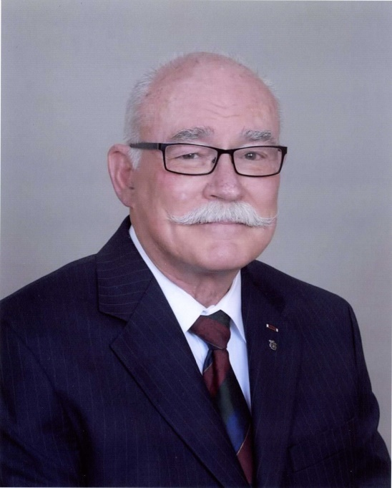 | 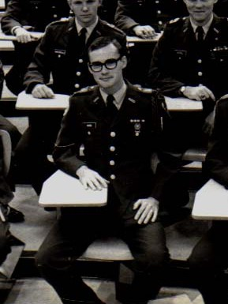
COL (Ret) Andrew C. Ward
Colonel (Retired) Andrew C. Ward is recognized by this induction into the Military Science Hall of Honor for his distinguished career and service to the nation that included outstanding accomplishments as a lifelong leader, both as an officer in the active Army, Army Reserve (USAR), and National Guard (ARNG), and as an innovator and developer of commercial credit policies, procedures, and organizations, domestically and internationally. Colonel Ward is a native of Dallas, Texas, and a 1966 graduate of Richardson High School. He enrolled at UT Arlington and joined ROTC the following semester. As a senior, Cadet Ward served as the Battalion XO, as Commander of the Insurgent Team, and as President of the Officers and Seniors Club. On the College of Business Dean’s List, he graduated from UTA in 1972 with a bachelor’s degree in business management and was commissioned an Armor Officer in the USAR.
Colonel Ward has served in Armor assignments throughout his thirty-year career in the Texas Army National Guard. He was a Scout Platoon Leader and Heavy Mortar Platoon Leader in the 49th Armored Division. He commanded a Combat Support Company from 1980 to 1982 and a Tank Company from 1984 to 1986. He later served as Battalion Operations Officer and Executive Officer for the 1st Battalion 112th Armor, and as the 3rd Armored Brigade Operations Officer. From 1996 to 1999, he commanded the 5th Battalion 112th Armor, 49th Armored Division, headquartered in Marshall, Texas. In 1999, Colonel Ward was assigned as the Deputy Chief, Joint Military Commission, SFOR 7 when the 49th Armored Division received its historic mission as the first National Guard Division Headquarters to command and control NATO and Multinational Forces in Bosnia Herzegovina. He assisted in forming and training the SFOR 7 Joint Military Commission and assisted in the training of two subsequent rotations while assigned as the 49th Armored Division Deputy Chief of Staff. He also served on the Board of Directors of the National Guard Association of Texas. Colonel Ward’s final assignment was as commander of the 142 Rear Operations Center (ROC), Texas Army National Guard. Colonel Ward’s military awards include the Legion of Merit and the Lone Star Distinguished Service Medal.
Colonel Ward balanced his military and civilian careers for over thirty years in positions that valued his experience in both fields. His distinguished civilian career included the application of commercial credit principals while he served as corporate and regional credit manager for multiple corporations. He received his professional certifications for International Certified Credit Executive (ICCE) and Certified International Credit Professional (C.I.C.P.) from the University of Michigan, through The Finance, Credit & International Business Association (FCIB). He developed policy, global operations initiatives, and improved communication capabilities between credit and sales while building effective high-performing teams. The integration and synergy between his corporate experience and military operations established Colonel Ward as an outstanding leader in both fields. In February 2018, when he retired after seventeen years with the A.E. Petsche Company /Arrow Electronics, Inc., he was responsible for the operation of the global credit and collection department for his company with 220 million dollars in global sales and specializing in the distribution of products supporting the military aerospace industry.
Colonel Ward and his wife Sharon currently reside in Arlington, Texas. They have two adult sons, Kyle and Thomas. Colonel Ward and Sharon balanced a military career and family responsibilities with a distinguished civilian career that demonstrate lifelong leadership in service to the nation and community.

