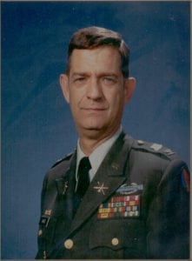 | 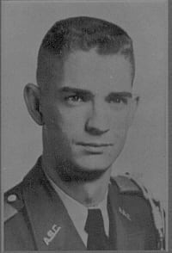
COL (Ret) Joel H. Ward
Colonel Joel H. Ward began his distinguished military career as a cadet at Arlington State College. He was a member of the Sam Houston Rifles and served as Executive Officer. He achieved the rank of Colonel on the Corps of Cadets and was the Corps Commander. He was also one of sixteen cadets to make the 160 mile march to summer camp at Fort Hood, Texas in 1960. This march heralded the first year for Arlington State cadets to attend summer camp as the college transitioned from a two-year college to a four-year university. He was a Distinguished Military Graduate with a Bachelor of Arts in History. He was commissioned Regular Army in the Air Defense Artillery. He is the first graduate of the University of Texas at Arlington to return as the Professor of Military Science.
He holds a Master of Arts degree in Business from Central Michigan University (1979). His military education includes the Air Defense Artillery Officer Basic Course (1963), the Air Defense Artillery Advance Course (1969), Foreign Service Institute (1970), U.S. Army Command and General Staff College (1973), Defense Language Institute (1980), and the U.S. Army War College (1984).
Colonel Ward’s initial duty assignment was to a Nike Hercules Battery at Fort Wolters, a part of the Dallas-Fort Worth missile defense. He subsequently was assigned to 2nd Region ARADCOM Headquarters and later to duty as a Deputy District Advisor in Vietnam in 1965. Upon returning to the United States, he commanded the 1st Special Training Company (Basic Combat Training) and later served as Assistant Chief of Training at Fort Gordon, Georgia. After a second tour in Vietnam as a District Senior Advisor, Colonel Ward, then Major, became Executive Officer of a Chaparral/Vulcan Air Defense Battalion at Fort Riley, Kansas. In 1973, he served as Plans and Operations Officer at Headquarters ARADCOM, and later as Operation Officer, Ballistic Missile Defense Operations Activity (SAFEGUARD) also located in Colorado Springs, Colorado. In 1976, he was reassigned to the Pentagon initially as an Inspector General, Department of Deputy Chief of Staff for Personnel. He was selected to command the 2nd battalion, 1st Air Defense Artillery (Nike Hercules) from 1980 to 1982, a nuclear capable battalion in West Germany. Upon completion of Battalion Command, Colonel Ward became the principal advisor to the Deputy-in-Chief, U.S. Army, Europe on nuclear, air defense artillery, and Pershing II missile matters. Colonel Ward then returned to the University of Texas at Arlington as Professor of Military Science. His last assignment was as Director of Air Defense Artillery Training and Doctrine (Patriot Missile) at Fort Bliss (El Paso), Texas.
His awards include three Bronze Stars for valor, two Meritorious Service Medals, four Army Commendation Medals, the Air Medal, two Vietnamese Crosses of Gallantry, and the Combat Badge.
Colonel Ward retired from the United States Army in April of 1988, and is presently a Vice President of NationsBank. He and his wife, Sue, have three sons, Joel II, Steven and Michael and a daughter, Christina.

