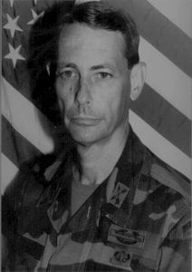 | 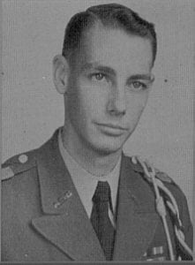

COL (Ret) Gary Weber
Colonel Gary L. Weber (U.S. Army, retired) graduated from Arlington State College (now UTA) in 1963. His military career began in the ASC Corps of Cadets, where he served as a member of the Sam Houston Rifles for four years. At graduation, he received a Bachelor of Arts degree in history, was named a Distinguished Military Graduate and was commissioned a second lieutenant in the U.S. Army.
Over the next 30 years, the Army took Col. Weber around the world, with two tours of duty in Vietnam and assignments in Greece and Panama as well as stateside. Along the way, he earned a Master of Science in Public Administration from Shippensburg University and taught Military Science at Central Michigan University. He also commanded the Honor Guard at 5th Army Headquarters, Fort Sam Houston, Tex.
In 1974, Col. Weber was assigned to the 10th Special Forces Group, Fort Devens, Mass., the start of his service with Special Forces and Intelligence units. He also served as Deputy Commander of the 5th Special Forces: Chief Reserve Component with the 1st Special Operations Command (Airborne), Commander of the 2nd Battalion 7th Special Forces Group; First Commander of the Special Operations Command, South (Airborne) in Panama; and an instructor at the Army War College. He concluded his military career at Fort Bragg, N.C. with assignments at the John F. Kennedy Special Warfare Center and the United Sates Special Operations Command (Airborne).
Col. Weber’s military awards and decorations include the Legion of Merit, Bronze Star Medal with two Oak Leaf Clusters, Air Medal (2nd award), Joint Service Commendation Medal, Army Commendation Medal with 1 Oak Leaf Cluster, Combat Infantryman’s Bade, Parachutist Badge, Special Forces Tab and the Canadian and French Parachutist Badges.
Since his retirement from the Army in 1994, Col. Weber has worked as Operations Analyst with Booze Allen and Hamilton in Tampa, Florida. He serves as a task leader and program analyst in developing Special Operations Forces Vision 2020 plan.
Co. Weber his wife Barbara have two children and two grandchildren. They reside in the Tampa, Florida Area.

