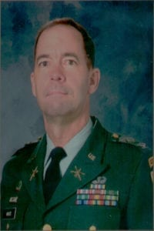
COL (Ret) Elmer Guy White III

Col. Elmer Guy White III attended UTA from 1972 to 1976. During his junior year, he served as cadet command sergeant major for the ROTC Corps of Cadets, and the following year he was both cadet corps commander and commander of the Sam Houston Rifles drill team.
He established the Scabbard and Blade Chapter during his tenure as commander, and was commissioned a Distinguished Military Graduate in the Air Defense Artillery in 1976. Col. White's military assignments have included tours of duty in Korea and Cuba.
He attended the Army's Command and General Staff College and the Army War College. In 1982, he was selected to attend the Defense Language Institute in Germany, where he completed the Russian basic course. He later attended the U.S. Army Russian Institute and was assigned to headquarters, U.S. Army Europe, where he served as a strategic intelligence officer.
He eventually earned a master's degree in Russian area studies from Georgetown University. From February to June 1996, Col. White commanded the Military Coordination Center in Zakho, Iraq, where he was responsible for conducting patrols of the security zone in northern Iraq to ensure the well-being of the region's Kurdish population. In 1997, he became chief of staff at the On-Site Inspection Agency in Washington, D.C.
Today he serves as the Army military attaché at the United States Embassy in Moscow. Col. White's military awards include the Defense Superior Service Medal, Defense Meritorious Service Medal, Army Meritorious Service Medal, Army Commendation Medal, Humanitarian Service Medal, National Defense Service Medal and the Coast Guard Meritorious Unit Citation. He and his wife, Diana, have three children.

