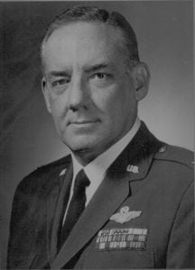 | 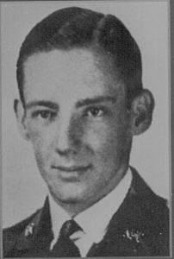
COL (Ret) Valin R. Woodward
Colonel Valin R. Woodward graduated from North Texas Agricultural College in 1940 and is honored for his long and illustrious military career. Commissioned Second Lieutenant, Army Air Corps on May 18, 1941, Colonel Woodward’s initial two years of service were as flight instructor at various air fields in Texas. In June of 1943, he was assigned to the 45th Bomb Group in England where he served as Flight Commander, Operations officer, Squadron Commander, and Group Operations Officer. He returned to the United States in July of 1945.
In August of 1945, Colonel Woodward assumed command of the 45th Bomb Group at March Field, California, and served as Commander, or Deputy, until the unit was dissolved in late 1945. For the next five years Colonel Woodward served in various staff assignments of attending service schools. In 1950, he was transferred to the Air Proving Ground Command as Inspector General of the Air Task Group 3.4 and participated in Operation Greenhouse, the 1951 nuclear tests in the Pacific. On his return, he was assigned to the Special Weapons Command, Kirkland Air Force Base, New Mexico.
In August 1955, he entered the Air Command and Staff College. Following graduation he was appointed Chief, Fire Control and Weapons Branch, Directorate of Research and Development, Headquarters USAF, Washington, D.C. In July 1958, he was assigned as Deputy Assistant DCS/Development for Foreign Developments, served in this capacity until January 1961.
From July 1961 to September 1962, Colonel Woodward served with the Air Section Military Advisory Group Germany. He was Chief of the Operations and Plans Branch. In December 1963, Colonel Woodward was selected to be Military Assistant to the Assistant Secretary of the Air Force. He served in this capacity until his retirement in March 1968.
Subsequent to his retirement, Colonel Woodward joined the Hughes Aircraft Company. In September, 1968 he became Manager of Hughes Aircraft International Service Company, Germany, the second largest Hughes International Operation in the world. In 1972, he and his wife established their own business in Albuquerque, New Mexico.
Among Colonel Woodward’s many awards and accomplishments are his establishing two speed records in August, 1946 in the P-80 jet fighter aircraft, and as Aircraft Commander of one of the few live nuclear test drops in the United States. He was also instrumental in planning an implementation of the F-104G aircraft and support system for both the United States and German Air Force.
His decorations include the Legion of Merit, the Distinguished Flying Cross with two Oak Leaf Clusters, the Air Medal with four Oak Leaf Clusters, the French Croix de Guerre with Star, various campaign medals, and Command Pilot and Glider Pilot ratings.

