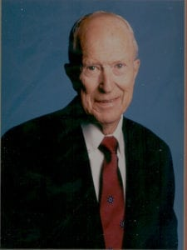 | 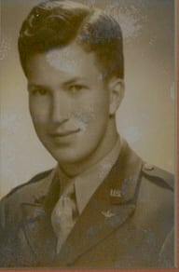
Dr. Jack R. Woolf
Dr. Jack R. Woolf, President Emeritus, Professor Emeritus is honored for a lifetime of distinguished service to the nation, the University, and support to the Corps of Cadets while President of The University of Texas at Arlington.
A native of Texas, he earned a BS and MS in Mechanical Engineering from Texas A&M. He enrolled in ROTC at Texas A&M and was in the Advanced Program while also serving in the United States Army Reserves. He entered active duty status in 1942, completed Officer Candidate School, and was commissioned in the Army Air Corps in 1944. He served as an Aviation Maintenance Officer and an Aviation Utilities Officer. His last assignment was as an Engineer Company Commander, Clark Field, Philippine Island. He left active duty in 1946 and resigned his reserve commission in 1953.
He obtained a Ph.D. at Purdue University in 1951 where he had been a Mechanical Engineering Instructor and Dupont Fellow since 1948. After five years as Engineering Supervisor with General Dynamics and as a Guest Lecturer at Southern Methodist University, he began to devote full attention to higher education. He was Professor of Mechanical Engineering, Research Engineer, and Assistant to the President at Texas A&M University in 1956.
He began an association with the University of Texas at Arlington (UTA) in 1957 that has continued for 36 years. His outstanding service has been marked with significant achievements for which he has received numerous honors. He served one year as Dean, Arlington State College in 1959. During his tenure as President, he led the University through years of significant change and unparalleled growth. He orchestrated the smooth transition from two-year to a four-year institution. He elevated the college to university status, supervised the transfer from the Texas A&M system to the University of Texas System, and was at the helm when the institution was renamed The University of Texas at Arlington in 1966. Throughout this evolutionary period, Dr. Woolf was a steadfast supporter of the Corps of Cadets. He supported the expansion of ROTC to a four-year program and saw the first eight cadets commissioned through UTA ROTC in 1961.
Dr. Woolf is a leading authority in the fields of heat transfer, thermodynamics, higher education, thermodynamics property relations and is well published in those fields. He has been a member of several technical and honor societies, military and civilian. He is the recipient of numerous honors to include: Outstanding Alumnus and Outstanding M.E. Alumnus, Purdue University; Arlington Man of the Year; Tarrant County Engineer of the Year; Paul Harris Fellow, Rotary International.
President Emeritus Jack R. Woolf relinquished the Presidency in 1968 to continue as Professor of Engineering and to become Executive Director, Association of Texas Colleges and Universities. He retired from full time duties in 1989, but continues his association with the College of Engineering.
Dr. Woolf and his wife Martha, reside in Arlington. They have two sons and two grandchildren.

