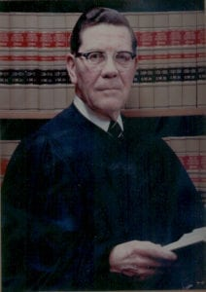 | 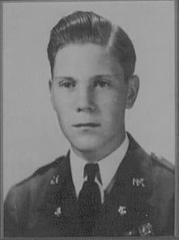
Judge James E. Wright
Judge Wright was born January 15, 1921 in Arlington, Texas. He attended North Texas Agricultural College (NTAC) graduating in 1940. During his tenure at North Texas Agricultural College, he was President of the Pre-Law Society known as the “Aggie Bar.” He was very active in many extracurricular affairs on the campus. He was a member of the ROTC Cadet Corps and attained the rank of Cadet Captain in the band.
Judge Wright served his country for four years as a glider pilot in the Troop Carrier Command during World War II. After the war, he attended The University of Texas at Austin where he received the Doctor of Jurisprudence degree in 1949.
Judge Wright was a trail lawyer for more than twenty years in Fort Worth, Texas and during that time also served as City Attorney for the City of Arlington from 1951 to 1961. He was President of the Fort Worth/Tarrant County Bar Association, the State Bar of Texas, Phi Alpha Delta (honorary legal organization), and the Fellows of the Texas Bar Foundation (honorary legal organization). He has served as Judge of the 141st Judicial District of Texas since October 1969.
He is a Mason, Shriner and a member of the Fort Worth Rotary Club (president from 1966-1967). He attends the First Methodist Church of Fort Worth where he serves on the administration board. He is also listed in “Who’s Who in America.”
Judge Wright has been and is a great supporter of the Corps of Cadets at The University of Texas at Arlington. In 1982, he was selected as Distinguished Alumnus of UTA. His continuing interest and support of many civic functions in the area have brought credit to himself, the legal profession and The University of Texas at Arlington.

