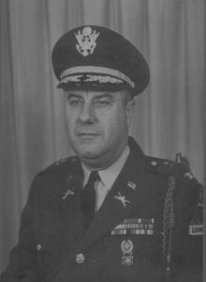 | 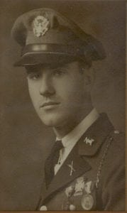
BG (Ret) Lynn M. Yeatts
Brigadier General Lynn M. Yeatts began his distinguished military career in 1932 by attending Civilian Military Training Camp and then enhanced his military skills by attending North Texas Agricultural College (NTAC) from 1932 to 1934. While at North Texas Agricultural College he was a member of the Corps of Cadets where he attained the rank of Cadet Lieutenant. He was commissioned as a Second Lieutenant of Infantry in 1934.
General Yeatts entered active duty in 1940 with the Second Armored Division. In 1942, he was transferred to the 746th Tank Battalion where he served as Operations Officer and Executive Officer. His battalion made the Normandy “D-Day” landing on June 6, 1944, and he continued in combat operations until the end of the war in Europe on May 8, 1945. He was then reassigned to the 739th Amphibious Tank Battalion training for combat in the Pacific Theater.
Following his discharge from active military service in 1946, General Yeatts became one of the original officers to form the new 49th Armored Division, accepting a reduction in rank to Major in order to participate in the Texas Army National Guard. Serving first as Executive Officer of the 145th Tank Battalion, he then assumed command in 1949, and was again promoted to Lieutenant Colonel. He commanded the Battalion through it reorganization to the 249th Heavy Tank Battalion when he became the Division G-4 in 1959. In April of 1960, General Yeatts assumed command of Combat Command A and was promoted to Colonel. He served in that capacity during the 49th Armored Division’s mobilization for the Berlin Crisis in 1963. General Yeatts was assigned as Assistant Division Commander in March 1965, and promoted to Brigadier General. He served in that position until his formal military retirement in July of 1965.
The bravery and devotion to duty of this outstanding soldier and commander have been recognized by numerous decorations and awards, to include: the Silver Star Medal; the Bronze Star Medal with “V” Device for valor, and with a Bronze Oak Leaf Cluster; the Army Commendation Medal; the Purple Heart; the American Defense Medal; The American Campaign Medal; the European-African-Middle East Campaign Medal with Arrowhead and five campaign stars; the World War II Victory Medal; The Army Occupation Medal; the National Defense Medal; the Armed Forces Reserve Medal with two ten-year devices; the Texas Meritorious Service Medal; the Texas Federal Reserve Medal with one Silver Service Star; the Texas Faithful Service Medal with three Cactus Leaf Clusters. General Yeatts was also entitled to wear the Belgian Fourragere.
He succeeded in service to his community as well, serving the City of Fort Worth as Director of Community Relations of the Fort Worth Transit Company until 1976.
General Yeatts died in Fort Worth, Texas on September 30, 1981.
General Yeatts’ outstanding accomplishments as a citizen soldier, his devotion to state and nation throughout his long, distinguished military and civilian career has brought honor to himself, The University of Texas at Arlington and the United States Army.

